**University Networking Project**

A COURSE PROJECT REPORT

By :-

**NIKHIL T PATIL [RA2111030010194]**

**VARUN RAMAKRISHNA IYER [RA2111030010218]**

**SRIJAN MISHRA [RA2111030010204]**

Under the guidance of   
**Dr. S. Murugaanandam**In partial fulfillment for the Course

of

18CSC202J - COMPUTER COMMUNICATIONS

Department of Networking and Communications - KTR 

**FACULTY OF ENGINEERING AND TECHNOLOGY**

**SRM INSTITUTE OF SCIENCE AND TECHNOLOGY**

**Kattankulathur, Chengalpattu District**

**Chennai, Tamil Nadu 603203**

|  |  |
| --- | --- |
|  | COLLEGE OF ENGINEERING & TECHNOLOGY  SRM INSTITUTE OF SCIENCE & TECHNOLOGY  S.R.M. NAGAR, KATTANKULATHUE – 603 203  Chengalpattu District |

**BONAFIDE CERTIFICATE**

Certified that this mini project report " **University Networking Project**" is the bonafide work of **NIKHIL PATIL [RA2111030010194], VARUN RAMAKRISHNA IYER [RA2111030010218] , SRIJAN MISHRA [RA2111030010204]** of II Year/IV Sem B.Tech Degree Course in the **Practical’s Computer Communication 18CSC202J** in **SRM INSTITUTE OF SCIENCE AND TECHNOLOGY,** Kattankulathur during the academic year 2022 – 2023.

**LAB INCHARGE HEAD OF THE DEPARTMENT**

**Dr. S. Murugaanandam Dr.Annapurani K**

**Associate Professor, Professor and HOD**

**NWC NWC**

**SRMIST – KTR. SRMIST – KTR.**

**TABLE OF CONTENTS**

|  |  |  |
| --- | --- | --- |
| **CHAPTER NO** | **TITLE** | **PAGE NO** |
| **1** | **ABSTRACT** | **5** |
| **2** | **INTRODUCTION** | **6** |
| **3** | **REQUIREMENTS** | **7** |
| **4** | **OBJECTIVES** | **9** |
| **5** | **NETWORK REQUIREMENTS** | **11** |
| **6** | **MAJOR DESIGN AND FUNCTIONAL AREAS** | **13** |
| **7** | **IP ADDRESSING PLAN** | **15** |
| **8** | **ROUTING PROTOCOL PLAN** | **17** |
| **9** | **NETWORK DESIGN** | **19** |
| **10** | **SUMMARY** | **20** |
| **11** | **REFERENCES** | **21** |

# ACKNOWLEDGEMENT

We express our heartfelt thanks to our honorable **Vice Chancellor Dr. C. MUTHAMIZHCHELVAN**, for being the beacon in all our endeavours. We would like to express my warmth of gratitude to our **Registrar Dr. S. Ponnusamy,** for his encouragement We express our profound gratitude to our **Dean (College of Engineering and Technology) Dr. T. V.Gopal,** for bringing out novelty in all executions. We wish to express my sincere thanks to **Course Audit Professor Dr. Annapurani Panaiyappan, Professor and Head, Department of Networking and Communications** and **Course Coordinators** for their constant encouragement and support.

We are highly thankful to our Course project Faculty **Dr. S. Murugaanandam, Assistant Professor, SRM Institute of Science and Technology,** for hisassistance, timely suggestion and guidance throughout the duration of this course project.

Finally, we thank our parents and friends near and dear ones who directly and indirectly contributed to the successful completion of our project. Above all, I thank the almighty for showering his blessings on me to complete my Course project.

**ABSTRACT**

Computer networks have a significant impact on the working of an organization. Universities depend on the proper functioning and analysis of their networks for education, administration, communication, e-library, automation, etc. An efficient network is essential to facilitate the systematic and cost-efficient transfer of information in an organization in the form of messages, files, and resources. The project provides insights into various concepts such as topology design, IP address configuration, and how to send information in the form of packets to the wireless networks of different areas of a University.

The aim of this project is to design the topology of the university network using the software Cisco Packet Tracer with the implementation of wireless networking systems. This university network consists of the following devices:

1) Router (1941)

2) Switches (2960-24TT)

3) Email server

4) DNS server

5) WEB server (HTTP)

6) Wireless Device (Access Point)

7) PCs

8) Laptops

9) Smartphones

The design includes the following parts of the University:

Hostel Blocks: Girls Block and Boys Block

Academic Blocks: AB1 and AB2

Dome Building and Library

IT Consulting

**INTRODUCTION**

Computer networks play a pivotal role in modern organizations, facilitating efficient communication, data sharing, and resource accessibility. Designing and managing these networks is crucial to ensure seamless connectivity and optimal performance. This project focuses on the detailed design of the University Network topology using Cisco Packet Tracer, a robust network simulation software.

The University Network serves as a fundamental infrastructure for academic institutions, enabling students, faculty, and staff to access educational resources, collaborate on projects, and communicate effectively. A well-designed university network empowers stakeholders with the ability to leverage digital tools, research databases, online learning platforms, and administrative systems.

Cisco Packet Tracer, developed by Cisco Systems, is a powerful network simulation tool widely used by network architects, engineers, and students. It provides a virtual environment where complex network topologies can be designed, configured, and tested without relying on physical hardware. Its intuitive interface and extensive feature set make it an ideal choice for simulating network infrastructures.

This College Network Scenario is about designing a topology of a network that is a LAN (Local Area Network) for a college in which various computers of different departments are set up so that they can interact and communicate with each other by interchanging data. To design a networking scenario for a college which connect various departments to each other's, it puts forward communication among different departments. CNS is used to design a systematic and well-planned topology, satisfying all the necessities of the college (i.e client). CNS come up with a network with good performance

# **REQUIREMENTS**

The success of any software project relies heavily on defining clear and comprehensive requirements:

Cisco Packet Tracer Software: Obtain and install the latest version of Cisco Packet Tracer software on your computer. The software is typically available through Cisco's website or educational institutions that have partnerships with Cisco.

Computer System: Ensure that your computer meets the minimum system requirements to run Cisco Packet Tracer effectively. These requirements may vary depending on the version of Packet Tracer and the operating system you are using. Generally, a modern computer with a decent processor, sufficient RAM, and ample storage space is recommended.

Network Design Specifications: Gather the specifications and requirements for the University Network. This includes understanding the size of the institution, the number of users, the types of devices (such as computers, printers, servers, and access points), the anticipated network traffic, and any specific needs or constraints of the network.

Network Hardware and Device Emulation: Familiarize yourself with the various networking devices commonly used in network infrastructures, such as routers, switches, firewalls, access points, and servers. Cisco Packet Tracer provides emulation capabilities for these devices, allowing you to simulate their functionality and interactions within the network.

Network Protocols and Technologies: Develop a good understanding of networking protocols and technologies, including TCP/IP, Ethernet, VLANs, subnetting, IP addressing, routing protocols (such as OSPF or EIGRP), and security mechanisms (such as VPNs or firewalls). This knowledge will help you design a robust and secure network topology.

Network Design Best Practices: Learn about network design best practices and principles. These include creating a hierarchical network design, ensuring

redundancy and fault tolerance, implementing appropriate security measures, and optimizing network performance.

Documentation Tools: Familiarize yourself with documentation tools or software, such as Microsoft Word or diagramming software like Visio, to create clear and comprehensive network documentation. This will help you effectively communicate the network design, configurations, and other relevant information.

Research and References: Conduct thorough research to gather information about network design methodologies, Cisco Packet Tracer tutorials, and real-world network deployment examples. Reference books, online resources, and forums can provide valuable insights and guidance throughout the project.

By fulfilling these requirements, you will be well-prepared to design the topology of the University Network using Cisco Packet Tracer effectively and efficiently.

# **OBJECTIVES**

# The objective of this project is to design the topology of the University Network using Cisco Packet Tracer, with the aim of creating a robust, scalable, and efficient network infrastructure that meets the communication and collaboration needs of the academic institution. By leveraging the capabilities of Cisco Packet Tracer, the project seeks to achieve the following:

# Network Planning: Analyze the requirements and specifications of the University Network, considering factors such as the size of the institution, the number of users, anticipated network traffic, and future expansion plans. This objective aims to ensure that the designed network topology can accommodate the institution's present and future needs.

# Topology Design: Create a logical and efficient network topology that provides reliable connectivity, minimizes latency, and supports seamless communication among students, faculty, and staff. The objective is to design the core, distribution, and access layers of the network, taking into account VLANs, subnetting, IP addressing, and routing protocols.

# Device Configuration: Implement device configurations within Cisco Packet Tracer to accurately reflect the designed network topology. Configure routers, switches, firewalls, access points, and other network devices according to best practices and industry standards. This objective aims to ensure that the network devices are properly configured to facilitate efficient data transmission and secure network operations.

# Testing and Optimization: Validate the network design by simulating various scenarios and test cases within Cisco Packet Tracer. This objective involves testing connectivity, assessing network performance, identifying potential bottlenecks or vulnerabilities, and optimizing the network for efficiency and resilience. The goal is to ensure that the network design can handle the anticipated traffic and maintain optimal performance.

# Documentation: Prepare comprehensive documentation that outlines the network design, including diagrams, IP schemes, configuration details, and any additional information necessary for network administrators and future expansions. This objective aims to provide network administrators with a clear reference for maintaining, troubleshooting, and scaling the network in the future.

# By achieving these objectives, the project aims to deliver a well-designed University Network topology using Cisco Packet Tracer, ensuring that the network infrastructure meets the institution's requirements for capacity, security, performance, and scalability.

**NETWORK REQUIREMENTS**

Network Requirements for Designing the Topology of the University Network using Cisco Packet Tracer:

Scalability: The network design should be scalable to accommodate the current and future growth of the university. It should support an increasing number of users, devices, and network traffic without compromising performance or stability.

Reliability: The network must provide reliable connectivity to ensure uninterrupted access to resources and services. Redundancy measures such as backup links, redundant hardware, and failover mechanisms should be implemented to minimize downtime.

Performance: The network should deliver optimal performance to meet the demands of data-intensive applications, online learning platforms, and collaborative tools. Low latency, high bandwidth, and efficient routing protocols should be considered to enhance user experience.

Security: The network design should prioritize security measures to protect sensitive data, academic resources, and personal information. Firewalls, access controls, intrusion detection systems, and encryption protocols should be implemented to safeguard against unauthorized access, data breaches, and network attacks.

VLAN Segmentation: Virtual LAN (VLAN) segmentation should be implemented to logically separate network traffic and improve security, manageability, and performance. Different VLANs can be established for administrative staff, faculty, students, and guest users.

Quality of Service (QoS): QoS mechanisms should be implemented to prioritize network traffic based on application requirements. This ensures that time-sensitive applications such as voice and video conferencing receive sufficient bandwidth and low latency.

Wireless Connectivity: The network design should incorporate wireless access points to provide reliable and secure Wi-Fi connectivity across campus. Adequate coverage, seamless roaming, and authentication mechanisms should be considered to support a mobile and connected environment.

Network Management: The network should be designed with effective network management in mind. This includes centralized monitoring, configuration management, and troubleshooting capabilities to efficiently manage and maintain the network infrastructure.

IP Addressing and Subnetting: Proper IP addressing and subnetting schemes should be established to efficiently utilize IP addresses, manage network segments, and ensure smooth communication between different network devices.

Compliance with Standards: The network design should adhere to industry standards and best practices, including protocols such as TCP/IP, Ethernet, and routing protocols like OSPF or EIGRP. Compliance with regulatory requirements, such as data privacy regulations, should also be considered.

By addressing these network requirements, the designed topology of the University Network using Cisco Packet Tracer will be capable of providing a scalable, reliable, high-performance, and secure network infrastructure that meets the specific needs of the academic institution.

**MAJOR DESIGN AREAS AND FUNCTIONAL AREAS**

The new system planned comprises of IP based switches that remain as the access point to Lan-based (Ethernet) as well as Wi-Fi-based connectivity.

These switches provide SNMP support as well so that traffic monitoring becomes easy. Ip based switches are used mainly because:

--> The inter VLAN routing feature is supported on both IP base or SMI and IP services or EMI image Layer 3 switches. For Layer 2-only switches, you require a Layer 3 routing device with any of the previous images.

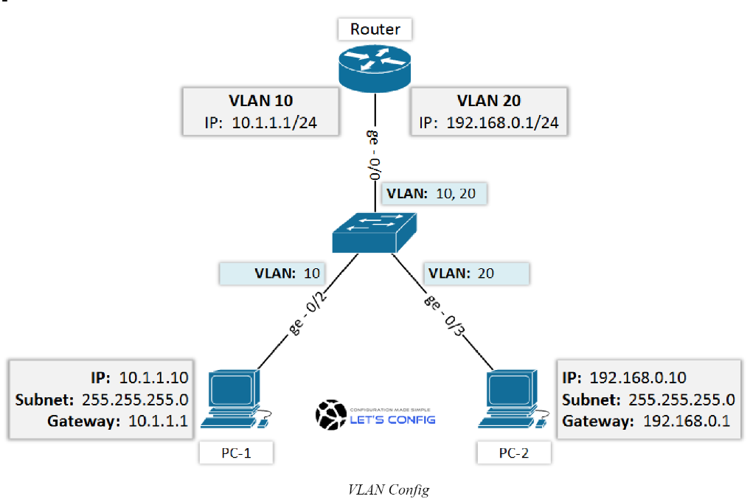

--> The IP Base feature set includes advanced quality of service (QoS), rate limiting, access control lists (ACLS), and basic static and Routing Information Protocol (RIP) functions. Dynamic IP routing protocols (Open Shortest Path First (OSPF), BGPv4, Enhanced Interior Gateway Routing Protocol (EIGRP)) are available only on the IP services image.

--> The IP Services image provides a richer set of enterprise-class features, which includes advanced hardware-based IP unicast and IP Multicast routing. Support for IPv6 Layer 3 switching in hardware is also available with the addition of the Advanced IP Services license to either the IP Base or the IP Services images. Both the IP base Image and the IP services image allow for Layer 3 and Layer 4 lookups for QoS and security.

**IP ADDRESSING TABLE**

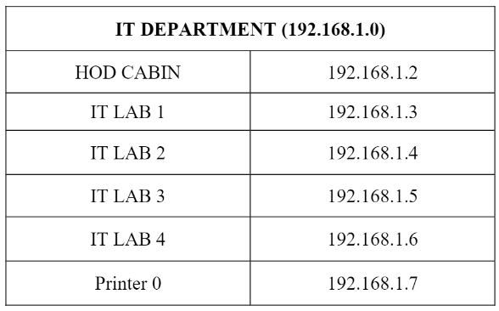

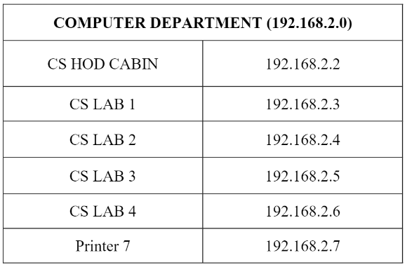

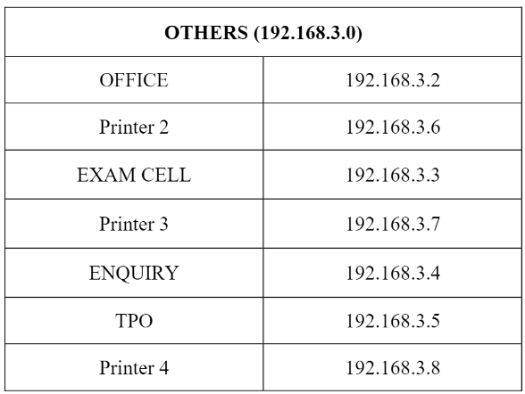

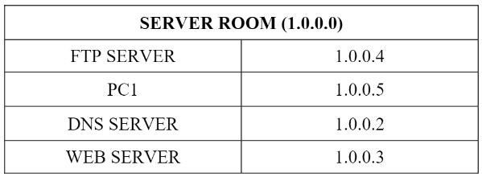

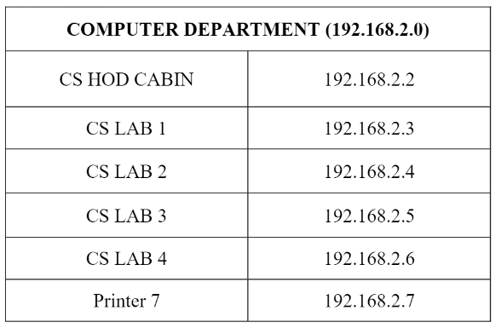

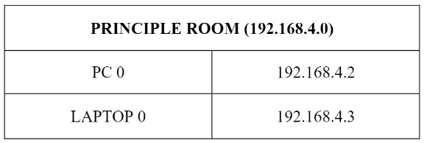

**ROUTING PROTOCOL PLAN**

Routing Information Protocol (RIP) is a dynamic routing protocol which uses hop count as a routing metric to find the best path between the source and the destination network. It is a distance vector routing protocol which has AD value 120 and works on the application layer of OSI model

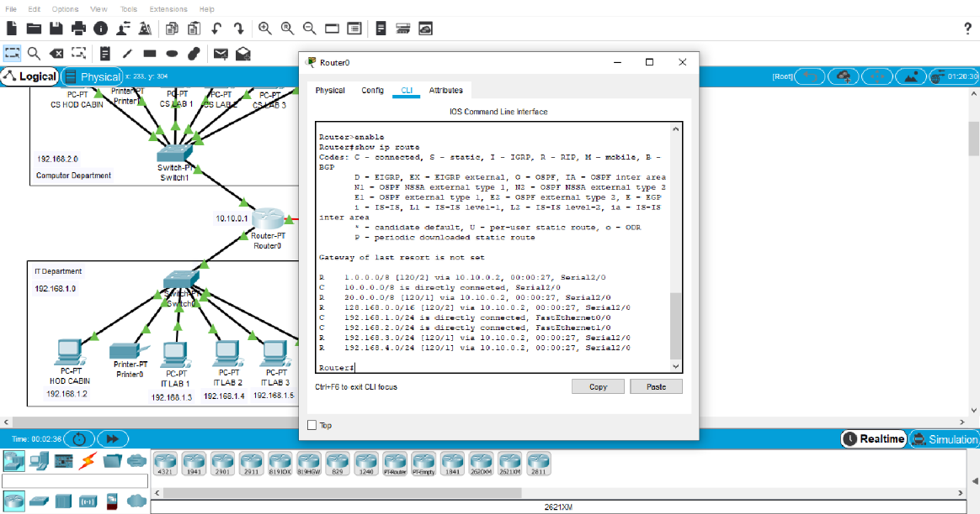

*For Router 1*

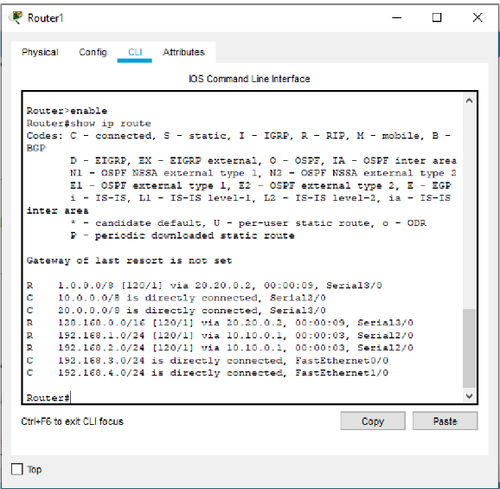

*For Router 2*

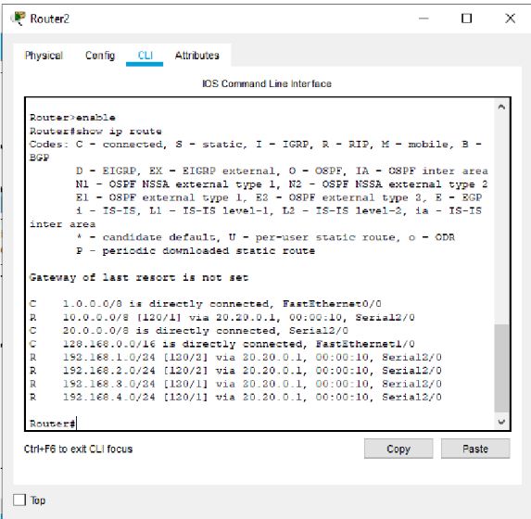

*For Router 3*

**NETWORK DESIGN**

The network design for the University Network will feature a hierarchical topology, consisting of core, distribution, and access layers. The core layer will include high-capacity routers to provide fast and reliable connectivity between different departments and external networks. The distribution layer will contain switches to aggregate traffic and implement VLAN segmentation for better security and manageability. Access layer switches will connect end-user devices, providing local network access. The design will incorporate redundant links and routing protocols like OSPF to ensure efficient routing and fault tolerance.

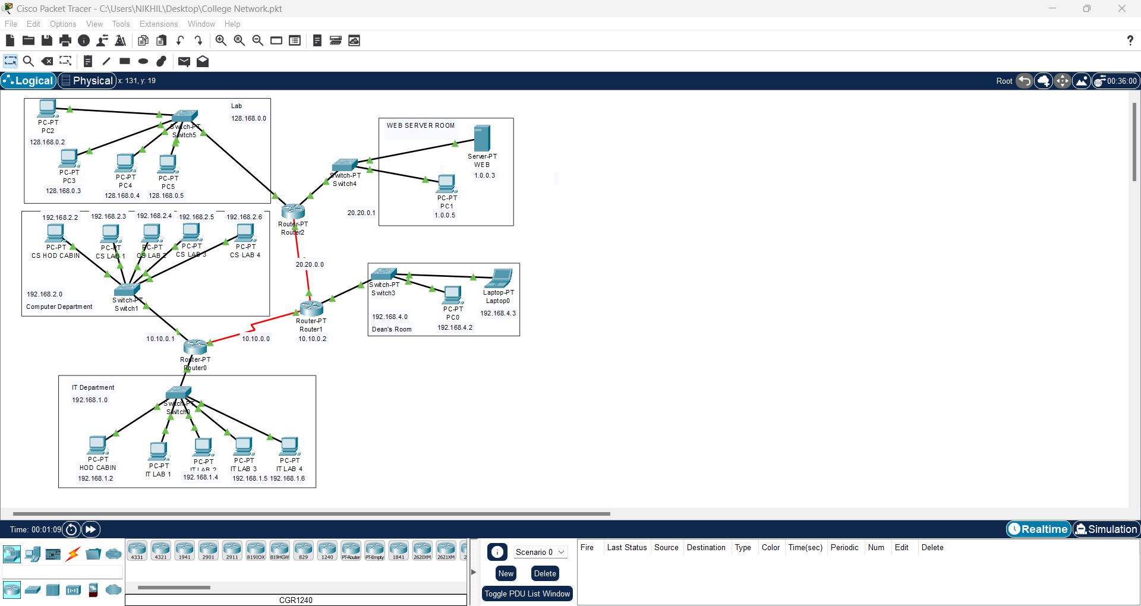

**SUMMARY**

The project focuses on designing the topology of the University Network using Cisco Packet Tracer, a network simulation software. The University Network serves as a critical infrastructure for academic institutions, enabling communication, collaboration, and access to resources. Cisco Packet Tracer provides a virtual environment for designing and testing network topologies without physical hardware.

The objectives of the project include network planning, topology design, device configuration, testing and optimization, and documentation. Network planning involves analyzing the requirements and specifications of the network, considering factors like size, users, and anticipated traffic. Topology design aims to create a logical and efficient network structure, while device configuration ensures proper configuration of routers, switches, firewalls, and other network devices. Testing and optimization validate the network design through simulation and identify potential improvements. Documentation provides comprehensive details for network administrators and future expansions.

The project requires Cisco Packet Tracer software, a suitable computer system, knowledge of network protocols and technologies, and understanding of network design best practices. The network requirements include scalability, reliability, performance, security, VLAN segmentation, QoS, wireless connectivity, network management, IP addressing, and compliance with standards.

By successfully designing the University Network topology using Cisco Packet Tracer and addressing the network requirements, the project aims to deliver a scalable, reliable, high-performance, and secure network infrastructure that meets the institution's needs.

**REFERENCES**

1. Sun, L., Wu, J., Zhang, Y., & Yin, H. (2013, April). "Comparison between physical devices and simulator software for Cisco network technology teaching". In Computer Science &Education (ICCSE), 2013 8th International Conference on (pp. 1357-1360). IEEE
2. Roberto Minerva AbiyBiru, "Towards a Definition of the Internet of Things” IEEE IOT Initiative white paper.
3. "Design and Simulation of Local Area Network Using Cisco Packet Tracer". The International Journal of Engineering and Science (IJES) || Volume || 6 || Issue || 10 || Pages || PP 63- 77 || 2017 || ISSN (e): 2319-1813 ISSN (p): 2319 – 1805.
4. Qin, X. U. E. "Simulation Experimental Teaching of Computer Network Based on Packet Tracer [J]." Research and Exploration in Laboratory 2 (2010): 57-59.

5) Current, John R., Charles S. ReVelle, and Jared L. Cohon. "The hierarchical network design problem." European Journal of Operational Research 27.1 (1986): 57-66.